STRASSEN’S MATRIX MULTIPLICATION
Strassen’s matrix multiplication is multiplying two square matrix. It seeks to decrease the total number of multiplying performed at the expense of a slight increase in the number of conditions. It by exploiting the divide and conquer idea.
The Strassen’s Matrix Multiplication find the product C of two 2 × 2 matrices A and B with just seven multiplications as opposed to the eight required by the brute-force algorithm.
The basic operation is multiplication operation.

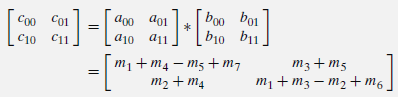
Consider,
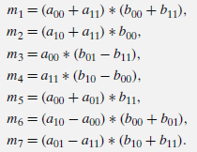
The resultant matrix can be obtained as,
c₁₁=m₁+m₄-m₅+m₇
c₁₂=m₃+m₅
c₂₁=m₂+m₄
c₂₂=m₁-m₂+m₃+m₆
Thus, to multiply two 2 × 2 matrices, Strassen’s algorithm makes 7 multiplications and 18 additions/subtractions, whereas the brute-force algorithm requires 8 multiplications and 4 additions. These numbers should not lead us to multiplying 2 × 2 matrices by Strassen’s algorithm. Its importance stems from its asymptotic superiority as matrix order n goes to infinity.
Let A and B be two n × n matrices where n is a power of 2. (If n is not a power of 2, matrices can be padded with rows and columns of zeros.) We can divide A, B, and their product C into four n/2 × n/2 submatrices each as follows:

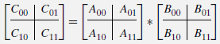

The value C₀₀ can be computed either as A₀₀ * B₀₀ + A₀₁ * B₁₀ or as M₁ + M₄ − M₅ + M₇ where M₁, M₄, M₅, and M₇ are found by Strassen’s formulas, with the numbers replaced by the corresponding submatrices. The seven products of n/2 × n/2 matrices are computed recursively by Strassen’s matrix multiplication algorithm.

Example problem:
Time complexity:
If M(n) is the number of multiplications made by Strassen’s algorithm in multiplying two n×n matrices,we get the following recurrence relation for it,
M(n)=7M(n/2) for n>1, M( 1)=1.
Since n=2^{k},
M(2^{k})=7M(2^{k}−1)
=7[7M(2^{k-2})]
=7² M(2^{k-2})
.
.
.
=7^{i} M(2^{k-i})
Substitute i=k,
M(2^{k})=7^{k} M(2^{k-k})
=7^{k} M(2⁰)
= 7^{k} M(1)
= 7^{k} * 1
= 7^{k} ------------------ (1)
Taking log on both side, n=2^{k}
log₂n= log ₂2^{k}
log₂n =k log ₂2
log₂n=k
k=log₂n

Sub k= log₂n and 2^{k}=n in the equation (1)
M(n) =7^{log}₂^{n}
=n^{log}₂⁷
≈n^{2.807}

